Application Note
Installing the Alternate USB Driver
November 26, 2002

This Application Note describes how you can install an alternate USB driver for use with your SBIG USB Cameras. After deploying hundreds of USB based cameras we found a handful of users were unable to establish a link with their USB cameras on some model PCs. The cameras would boot, indicated by the Led and Fan coming on a few seconds after powering up the camera and attaching it to the USB port. Further, the camera would show up in the Device Manager as “SBIG USB Camera” under the USB section but you could not establish a link to the camera with CCDOP or any other third party software. It appears is though the cause of this problem is a minor incompatibility in SBIG’s USB driver with some motherboards or USB chip-sets. To remedy this problem SBIG provides an alternate USB driver. This Application Note describes how to install that alternate driver.

Step 1 – Telling CCDOPS and Third Party Software packages to use the Alternate Driver
The first thing you need to do is run the SBIGDriverChecker utility (version 1.12 or later). As shown in the figures below, click on the Sel USB Drvr button then in the dialog that pops up select the SBIG Alternate driver and hit OK. At this point, the final entry in the Driver Name table should be sbigusbi.sys indicating the alternate USB driver. For reference the standard USB driver is sbigusbe.sys. Finally, click the Update button to copy all the latest drivers to your Windows System directory.

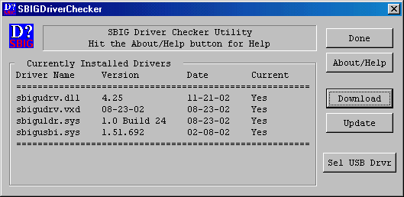

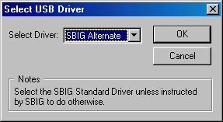

Step 2 – Installing the Alternate Driver, letting Windows know
Once the proper drivers have been copied to the Windows System directory you need to tell Windows to associate the alternate SBIG USB driver with the SBIG USB cameras. This is done through the Device Manager control panel. On some systems the Device Manager is part of the System Control Panel and on other systems it is a separate Control Panel.
With the SBIG camera plugged in and powered up first verify that the camera boots (the Fan and LED turn on) and that the camera is listed in the USB section of the Device Manager. Next click on the SBIG USB Camera item to select it then click the Properties button. Click the Driver tab then click the Update Driver button. At this point you are presented with the Update Driver Wizard dialog. Click the Next button then select the Display a list of all the drivers in a specific place radio button then click Next. Click the Have Disk button followed by the Browse button.
Browse to the SBIG Drivers -> Alt Drivers directory where you installed the SBIGDriverChecker utility (typically the CCDOPS directory) then select the sbigusbi.inf file then click OK then OK again. You should see the following:

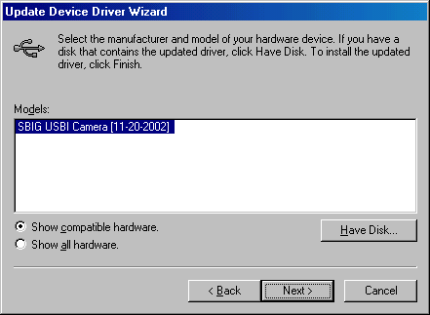

At this point you have selected the SBIG Alternate USB driver as indicated by the SBIG USBI Camera name shown above. Finally click Next, Next and Finish to install the driver.

Step 3 – Testing the Alternate Driver with CCDOPS
At this point you should be able to run CCDOPS, select USB in the Graphics/Com Setup command in the Misc menu then use the Establish Com Link command in the Camera menu to establish a link to the camera. Furthermore you should also be able to connect to the camera with third party software packages that support the SBIG USB camera like CCDSoft and MaximDl.

